Session 3

- Given an array of daily step counts from your fitness app for one week (e.g., [4500, 7000, 5000, 8000, 4000, 9000, 6000]), calculate the variance by hand using the variance formula and show each calculation step.
Step 1: Mean
Mean=4500+7000+5000+8000+4000+9000+60007 = 43500 / 7 = 6214
Step 2: Squared Deviations
Steps | x | x − Mean | (x − Mean)²
1 | 4500 | −1714.29 | 2938775.51
2 | 7000 | 785.71 | 617346.94
3 | 5000 | −1214.29 | 1474489.80
4 | 8000 | 1785.71 | 3188775.51
5 | 4000 | −2214.29 | 4903061.22
6 | 9000 | 2785.71 | 7760204.08
7 | 6000 | −214.29 | 45918.37
Step 3: Variance
Variance=20928657.14 / 7 = 2,989,808.16
Answer: Variance = 2,989,808.16
2.Write a Python function called calculate_standard_deviation(scores) that takes a list of exam scores and returns the standard deviation rounded to two decimal places.

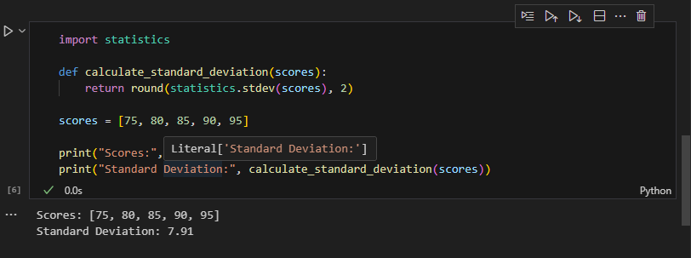

3.Imagine two friends track their daily spending on Zomato over 5 days. Friend A spends [200, 200, 200, 200, 200] and Friend B spends [100, 300, 150, 400, 50]. Calculate the standard deviation for both and explain in 2-3 lines who has more consistent spending and why.
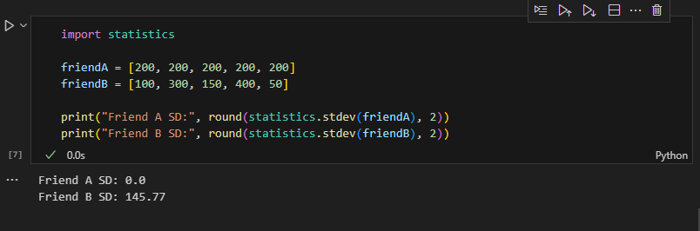
Friend A has a standard deviation of 0, meaning the spending is exactly the same every day. Friend B has a much higher standard deviation, showing that the spending varies a lot. Therefore, Friend A is more consistent.
4.You are given the monthly salary data of 6 employees in a startup: [28000, 29000, 27000, 60000, 26500, 27500]. Calculate the variance and standard deviation, then interpret in 2-3 lines what the high or low spread means for this team.
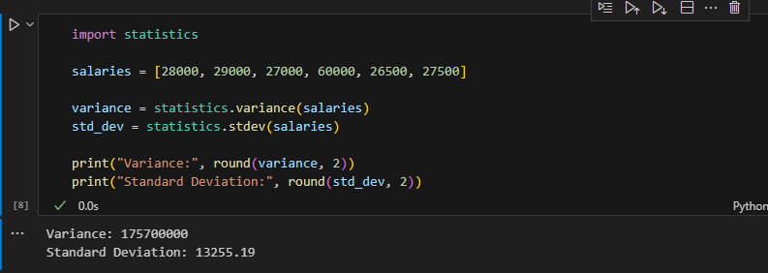

The standard deviation is high, indicating that the salaries are spread out over a wide range. This is mainly because one employee earns ₹60,000, which is much higher than the others. A high spread means the salaries are not evenly distributed.

